**DESIGN OF NON-LINEAR CONTROLLER FOR GLUCOSE-INSULIN HOMEOSTASIS**

**Report Submitted**

**by**

**SAMEER PURWAR (1401EE37)**



**DEPARTMENT OF ELECTRICAL ENGINEERING**

**INDIAN INSTITUTE OF TECHNOLOGY PATNA**

**November2017**

**Objective**

The main objective is :

* To study various glucose-insulin homeostasis model and the advantages and disadvantages of these model over each other.
* To study various mathematical modelling algorithm used for solving these model.
* To come up with a model and a control algorithm which can be successfully implemented on a embedded system which can then be used as an artificial pancreas (a control system with both controller and observer).

**Motivation**

Globally, an estimated 422 million adults were living with diabetes in 2014, compared to 108 million in 1980. Diabetes caused 1.5 million deaths in 2012. It was the eighth leading cause of death among both sexes and the fifth leading cause of death in women in 2012. Diabetes is a chronic, progressive disease characterized by elevated levels of blood glucose known as hyperglycemia. Diabetes of all types can lead to complications in many parts of the body and can increase the overall risk of dying prematurely.

There are mainly two types of diabetes -

Type 1 DM results from the pancreas failure to produce enough insulin

Type 2 DM begins with insulin resistance, a condition in which cells fail to respond to insulin properly.

Insulin injection or doses are required to regulate the blood glucose level in our body, but the limitation of the current management is the death of a large no of patients by hypoglycaemic shock due to overdose of insulin as the dose is calculated manually. Around 2-4% of patients with T1DM die due to hypoglycemic shock. Also in case of T2DM using insulin doses turns out to be a better and cheaper way of dealing with the complications.

Researches are ongoing, to create an artificial pancreas which can automatically regulate the blood glucose level in the body by releasing appropriate amount of insulin in the body depending upon the glucose measurement alone.

**Introduction to the Model**

Development of a control system include three main steps – Modeling, Analysis and Control Algorithm. Of these three steps modeling is the most important, because the model chosen should be closely related to the real world physical system being modeled, and at the same time should be simple enough so that analysis can be made. Keeping in mind both the accuracy and simplicity we opted for the Bergman minimal model which was published in 1981 and was developed to analyze the IVGTT test data, and has proven accurate with certain flaws, like it does not account for the glucagon kinetics and tends to overestimate the Glucose Effectiveness and underestimate Insulin Sensitivity.

You can also use other complicated models, with several compartment and states, to describe the glucose-insulin metabolism like the Sorenson model(a six compartment model with) or the Parkers model. Complex models though are accurate for evaluation but are generally unsuited for real-time control due to the fact that they need several time points of input to produce the insulin infusion profile. Additionally, they are not generic requiring the data of a specific patient and known glucose inputs. Against, simple models which capture essential dynamic behaviors and provide a more suitable foundation for real-time control design.

One such model as stated earlier, was introduced in the eighties by Richard N. Bergman and is called Bergman’s minimal model. The model has been modiﬁed and examined several times. We are going to discuss about the Bergman’s minimal model.

**Bergman’s Minimal Model**

**The Model**

Bergman’s minimal model is a three compartment model, meaning that the body is described as compartments/tanks with a basal concentration of glucose, insulin and active insulin. The minimal model actually contains two simple models, one describing the glucose kinetics, and the other describing the insulin kinetics. The two models take insulin and glucose data respectively as their input. The two models have mostly been used to interpret the kinetics during the IVGTT test, and in their original form they are not of much use otherwise, but with small alteration, they can also be used to model meals and exogenous insulin infusion for a person suffering from Type I diabetes mellitus.

In the section below a description of the glucose kinetics and insulin kinetics is given and finally the coupling of these two kinetics has been described, which could be used as simulate the entire blood glucose-insulin system. To account for the external meal disturbance, Fisher’s meal disturbance model has been used.

**Glucose Minimal Model**

**fig1 : Glucose Minimal Model with two compartment**

The original glucose minimal model describes how the glucose level behaves according to measured insulin data during an IVGTT. The model is a two compartment model, with glucose and active insulin compartments with G(t) and X(t) as their concentration.

The ﬁrst equation is the main part describing the glucose clearance and uptake. The second equation describes the delay in the active insulin X(t) which directly affects the uptake of glucose by the tissues and the uptake and production by the liver rather than the blood insulin. These two parts are described mathematically by two diﬀerential equations namely :

Part1 : Glucose differential equation

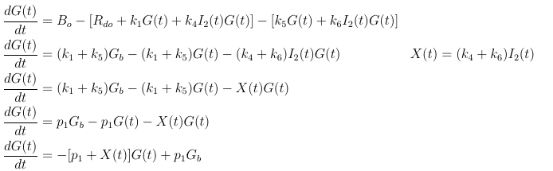

Part2 : Insulin differential equation

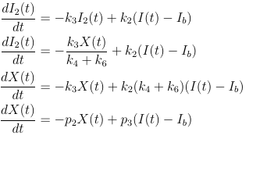

Parameter Unit Description

k1 [1/min] Glucose ability to increase uptake by the peripheral

k2 [1/min] Insulin transport rate to remote pool

k3 [1/min] Rate of clearance of active insulin

k4 [L/(min · mU)] Active insulin eﬀect on uptake by the peripheral

k5 [1/min] Glucose ability to change NHGB

k6 [L/(min · mU)] Active insulin eﬀect on NHGB

This set of differential equation described above takes blood insulin concentration as their input and provides glucose and active insulin concentration as their output. Such problem which requires solving of differential equation with time inputs is known as distributed data ODE problem, and uses iterative algorithm like Gauss Newton algorithm. In matlab you can implement them using nlinfit.

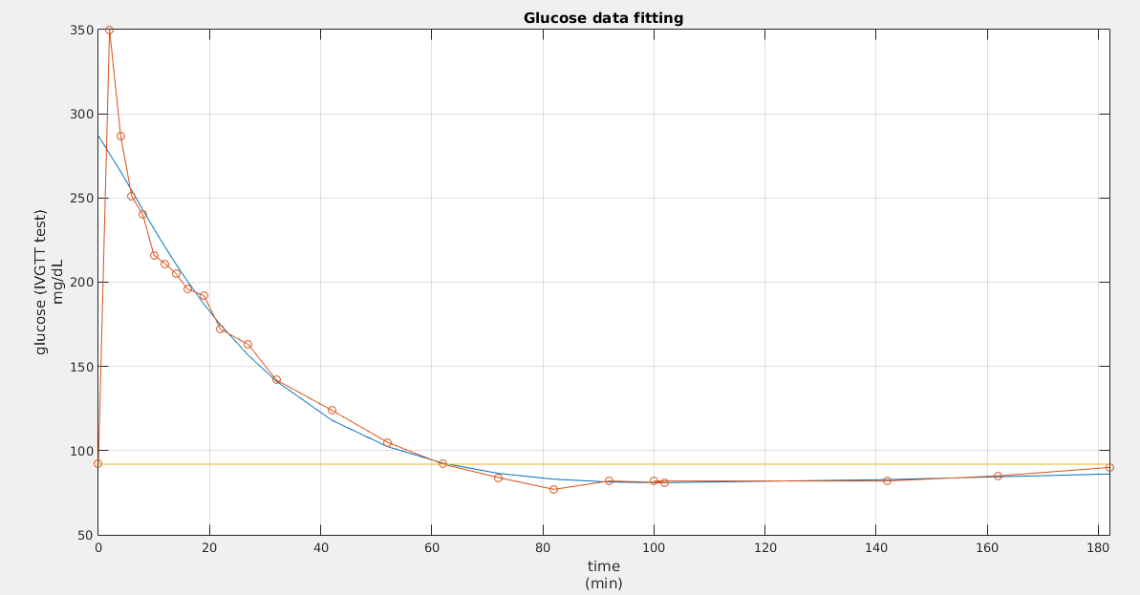 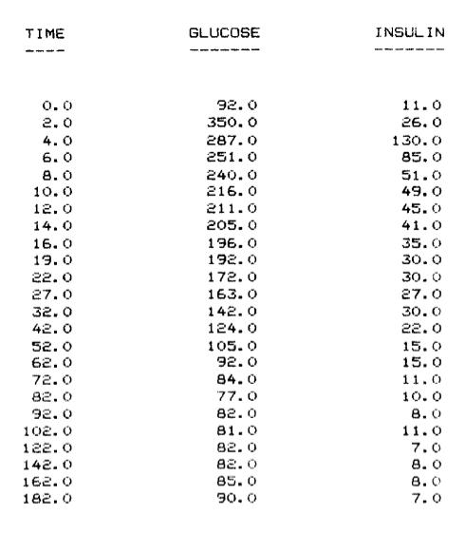

**Fig2: Glucose profile using the model and insulin input as data Table1: IVGTT test data from MINMOD paper**

**Insulin Minimal Model**

Now the model describing glucose kinetics as a product of insulin data input has been described. But a description of the insulin kinetics is missing. Bergman presented the following minimal model of insulin kinetics, given by the diﬀerential equation:

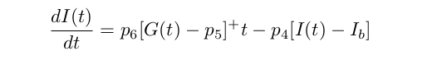

**Fig3: Insulin minimal model**

Like the glucose model, this insulin model is used to interpret the IVGTT, and like the glucose minimal model, a derivation, based on the rule of mass balances is used to describe it. The derivation is based on assumptions by Bergman. The parameters used are:

Parameter Unit Description

I(t) [mU/L] Blood insulin concentration

Ib [mU/L] Basal blood insulin concentration

G(t) [mg/dL] Blood glucose concentration

p5 [mg/dL] Threshold for blood glucose concentration

In a non type 1 diabetic subject, which this model can be used to describe, the pancreas is the source of insulin. In a healthy person a small amount of insulin is always created and cleared. This helps to keep the basal concentration Ib. The glucose independent production and the clearance of insulin is proportional to the blood insulin concentration. If the insulin level is above basal concentration the clearance increases, if the insulin level is below basal concentration the basal production increases. When the glucose level gets high the pancreas reacts by releasing more insulin at a certain rate. To explain this mathematically you have to derive a mathematical function describing the reaction of the pancreas. The term used to describe the effect of glucose on insulin is [G(t)−p5]+ which has the value G(t)−p5 when positive and zero when negative. So p5 is the limit deciding when the pancreas should produce more insulin and when to stop. And the diﬀerence between G(t)−p5 determines the rate at which the pancrease should produce insulin. The downside about this function is that it is very attached to the IVGTT. The ﬁrst peak is not described by this pancreas function but should be given as the initial value of the insulin concentration I(0). The pancreas function describes the second peak. The multiplying by time as shows that the pancreatic response being proportional not only to the hyperglycemia attained but also to the time elapsed from the glucose stimulus.

In this model Glucose act as input and insulin output profile is created from the differential equation.

**The Coupled Bergman Model and the Modified Bergman Model**

Glucose model and the Insulin model are coupled, which are able to interpret the IVGTT test and provide us with valuable information like Glucose effectiveness and Insulin Sensitivity.

In case of IVGTT test, a person is made to fast for about 8 hours before injecting the glucose in the body, then at fixed interval of time, both the glucose and insulin is measured. The measured data act as an input for the above discussed models.

Now to model the real life situation, we need to include the meal disturbance and for this we are using the fisher meal model, and instead of measuring the blood glucose we are going to measure the subcutaneous glucose. Since we are modeling for the person who won’t be able to produce insulin, that is also reflected in the insulin kinetics equation. In case of glucose and extra term D(t) is added to take meal into account, which is nothing but glucose disturbance whose dynamics is defined by the fisher meal model as a exponential decay equation. Insulin kinetics equation is adjusted to capture the dynamics of the patient suffering from T1DM, as the body itself does not produce insulin, instead a term U(t) is added which is the external insulin provided by the controller depending upon the glucose measurement.

After making these adjustments the model looks like –

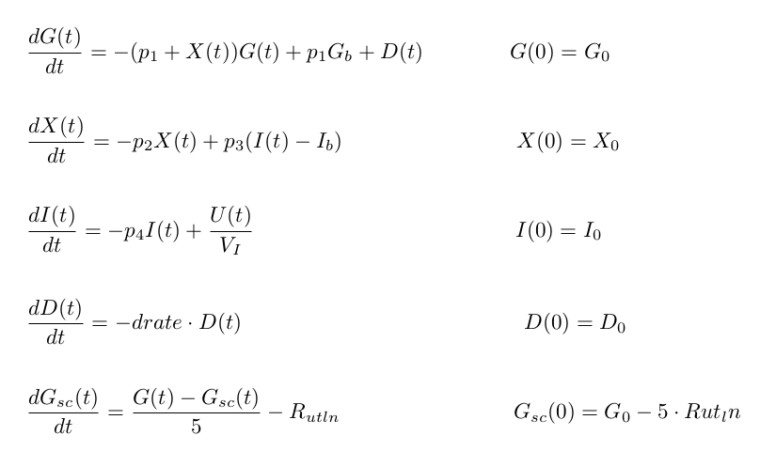

Where U(t) is the insulin input given from the controller or from outside. One has to keep in mind that this model is for the TIDM as we can see from the insulin kinetics equation that no insulin is being produced by the body.

**Controller Design**

For controller design, I have made use of PID controller, which takes error (Gset - Gmeasured) as input and outputs the insulin to be injected into the body denoted by U(t) in the modified Bergman model. For the tuning of the controller I have made use of Matlab.

**Result**

You can find all the simulink and matlab file on the GITHUB link provide:

https://github.com/sameerpurwar/Btech_Project_4th_Year

Before running the simulink model for result1, result2 and result3 run this file.

data.m

**result1** : Glucose Minimal Model using Insulin data from IVGTT test. (glucose_minimal_model.slx)

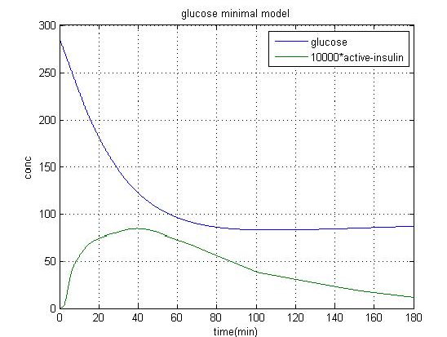

**result2**: Insulin minimal model using Glucose data from IVGTT test. ( Insulin_Minimal_model.slx)

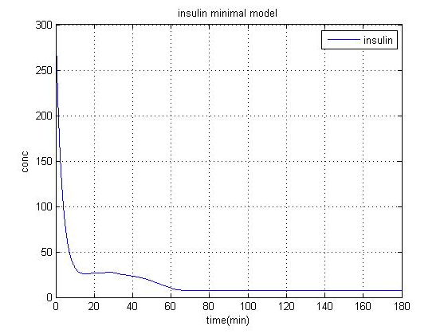

**result3**: Coupled Bergman Model(coupled_model.slx)

Before running the simulink model for result4, result5 run this file.

Modified_Bergman.m

**result4**: Modified Bergman(modified_bergman_model.slx)

**result5**:PID controller(coupled_model.slx)

**Conclusion and Future-Work**

As shown in the results, the model works fine with the IVGTT test data (result1 & result2) which consolidates the fact that the model is accurate enough and the evaluation works fine. Also the modified minimal model for a non-diabetic model tends to converge even in case of open loop or when no insulin is provided but it takes more time and glucose concentration might rise to a very high value in between. In case of PID controller, the glucose converges to Gset, the only drawback is that the X(t)[active insulin] becomes negative when using the controller, which should not happen. It raises doubts about the model itself which should be dealt with, without moving further.

As per the future work is concerned I am currently working on Linear Quadratic Control Algorithm(LQR) which is related to Algebraic Riccati Equation, I will then start working on the non-linear controller like SDRE tracker.

**References**